BIT 4107 – Mobile Application Development
ENHANCED PROFESSIONAL STUDENT LOGBOOK
Student Name: _FAITH NJERI NDEGWA_____________________________
Admission Number: _ ____________ BIT/2024/54252_________________
School/Faculty: ________MKU______________________
Programme: _____ Mobile Application Development ____________________
Academic Year: ________3rd YEAR_____________________
Semester: __________2.2___________________
Lecturer: ___________MICHAEL NYORO___________________
Phone Number: ________0790661387______________________

Instructions
This logbook is used to document weekly learning activities, practical exercises, skills acquired, challenges encountered, solutions applied, and reflections. Students should complete all sections every week.
Each week to follow remarks in week 1 section.

Autogenerated Table of content

Week 1: Introduction to Mobile Application Development

Practical Activities Undertaken
Installation process
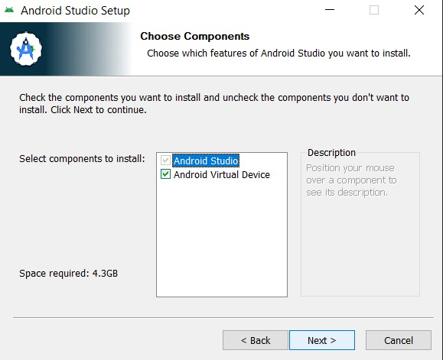

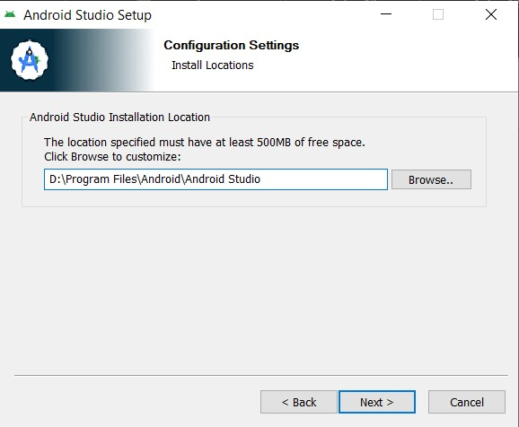
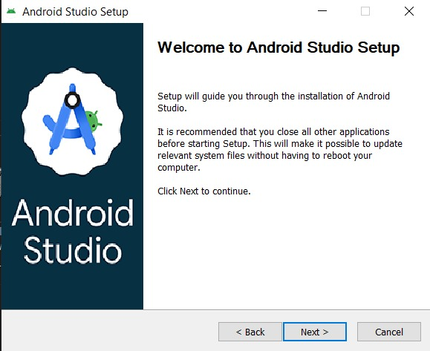

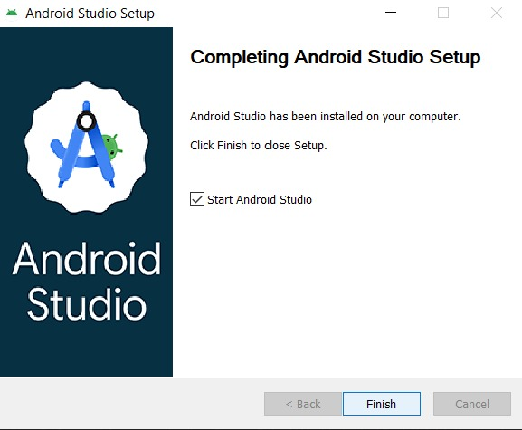

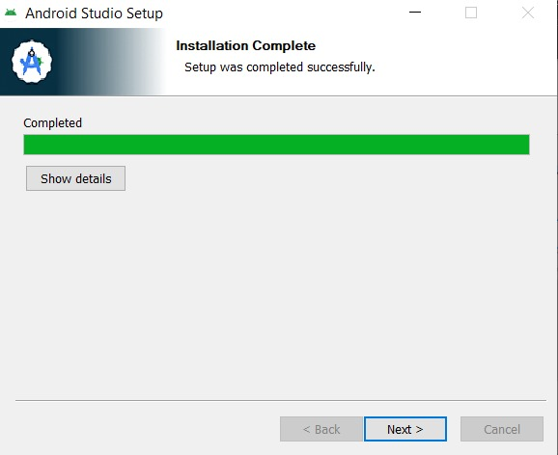

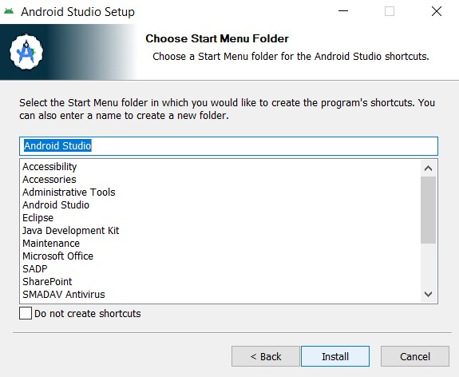

Tools/Software Used
Tool Used : Android Studio (with Kotlin/Jetpack Compose)

Personal Reflection
Reflection (Less than 50 words):
Through developing the SchoolLink app, a student should learn mobile application development, user interface design, navigation between screens, debugging, and testing on a real device. The project also builds problem-solving skills and demonstrates how technology can improve communication between schools and parents.

Week 2: Mobile Development Environment
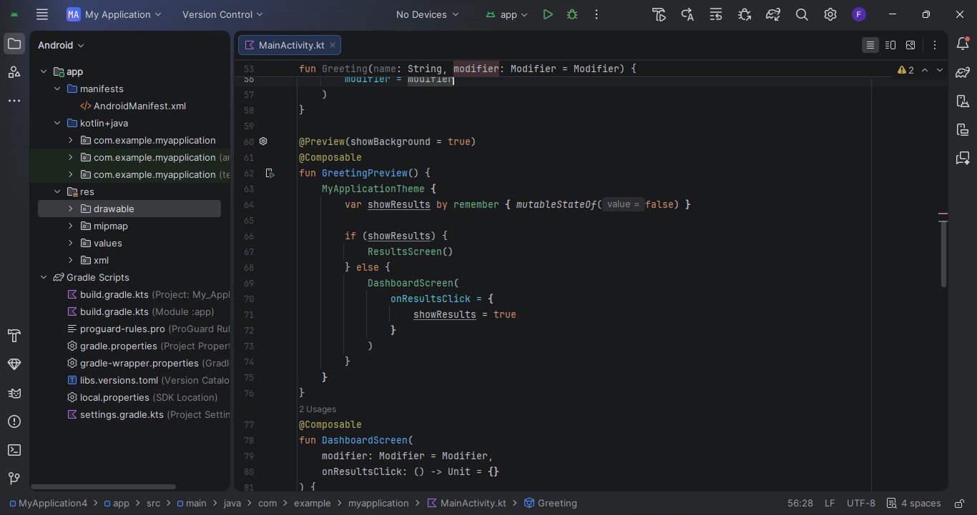
- Opening and setting up android studio
- Deciding and designing what i want to make

Week 3: User Interface Design
A screenshot of creating a user interface and linking then tasks together
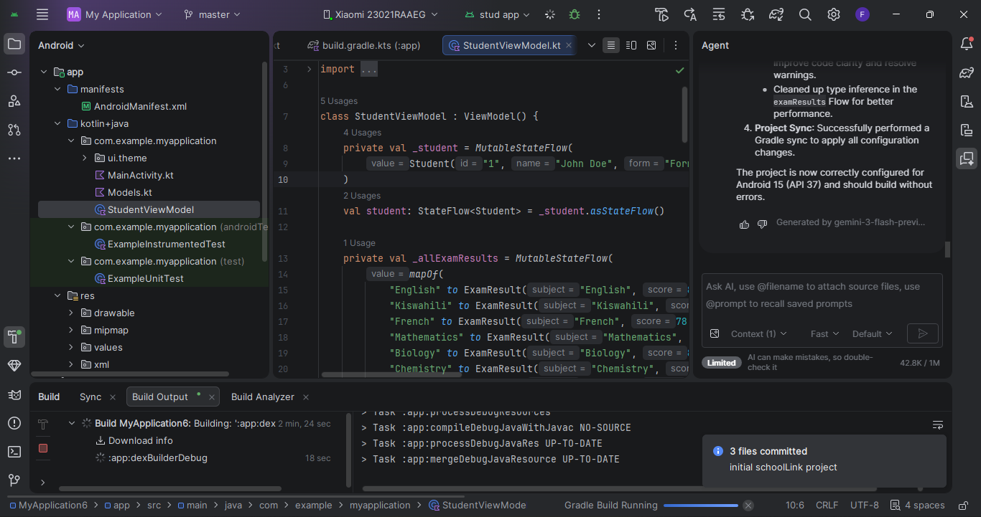
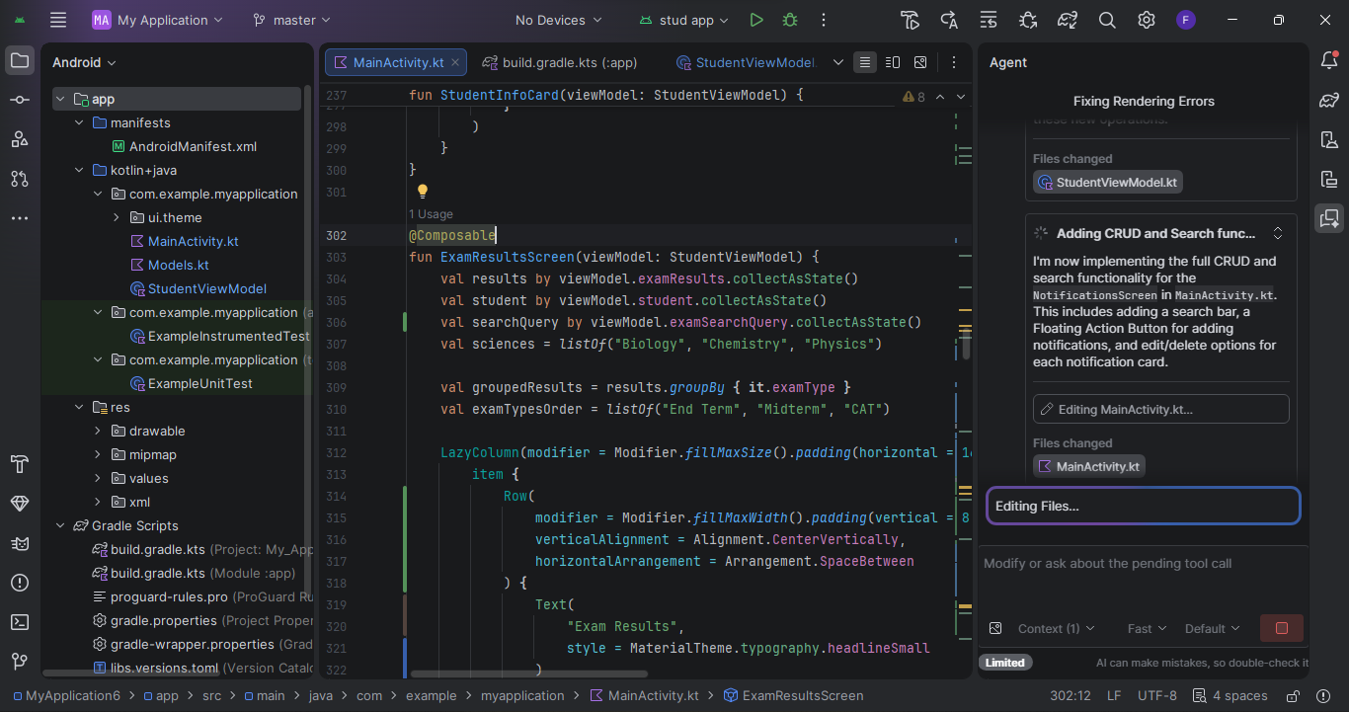
Tools used: Android studio, Java, Kotlin

Week 4: Event Handling and User Interaction
LINKING MY PHONE AND ENABLING ACTIVITIES TO RUN ON THE PHONE
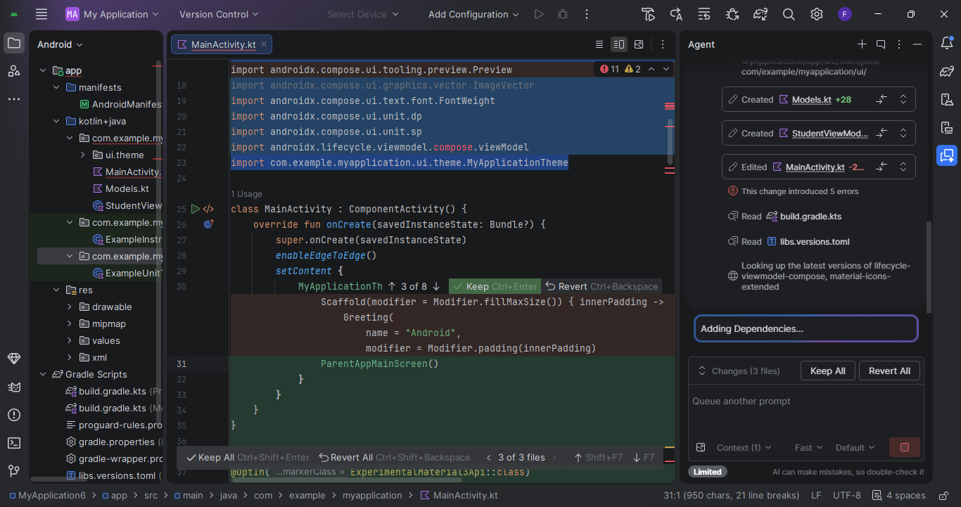

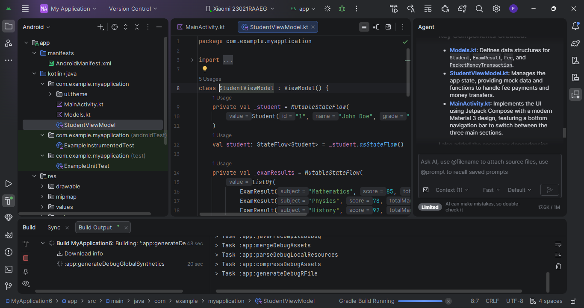

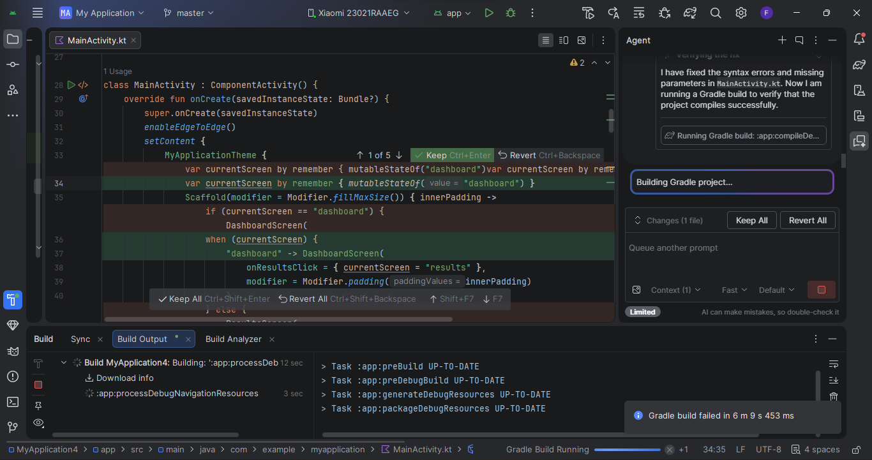

Week 5: Data Management

Same as week 1

Week 6: Networking and APIs

Same as week 1

Week 7: Application Architecture

Same as week 1

Week 8: Project Planning

Week 9: Device Features and Sensors

Same as week 1

Week 10: Notifications and Background Services

Same as week 1

Week 11: Mobile Security

Same as week 1

Week 12: Testing and Debugging

Same as week 1

Week 13: Application Deployment

Same as week 1

Week 14: Final Project Presentation

Same as week 1

Semester Project Tracking

Project Title

Project Objectives

Project Requirements

Development Milestones

Testing Results

Lessons Learned

Future Improvements

End of Semester Reflection

Summary of Skills Acquired

Most Interesting Topic

Major Challenges Faced

How Challenges Were Overcome

Professional Growth Achieved

Overall Course Experience

Final Approval
Student Name: __________________________
Student Signature: ______________________
Date: _________________________________
Lecturer Name: _________________________
Lecturer Remarks: _____________________
Date: _________________________________

